The First Church Sermon
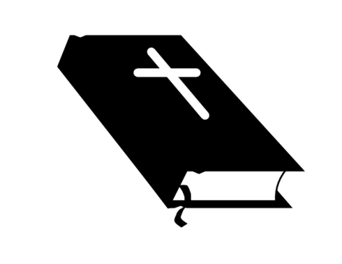
1. Peter’s ___________ Acts 2:14-16
a.______________________________
b.______________________________
c.______________________________
2. Peter Recites _________
1. They were _______in the last days.
2. Many of these signs___________happen.
3. The _______is for those who call on the name of the Lord.
3. Peter __________ Christ
a. Peter talks about _____________________
b. Peter talks about__________________
c. Peter talks about __________________
The Two Men
Jesus
- ________
- _________
- Will sit on that ___________
David
- ________
- _________
- Descendant on the __________

